**Department of Computing**

**CS-213: Advanced Programming**

**Class: BSCS 7AB**

**Lab 08: React JS**

**Date: 07 November, 2019**

**Time: 10:00-01:00pm & 02:00-05:00pm**

**Instructor: Dr. Sidra Sultana**

**Lab Engineer: Ms. Ayesha Asif**

**Name: Tatheer Zahra**

**Reg# 211972**

**Lab 08: ReactJS States**

1. You have to practice the states codes covered in class lecture

Code 1:

import React,{Component} from 'react';

import ReactDOM from 'react-dom';

class Welcome extends Component {

constructor(){

super()

this.state={message:"welcome visitor"}

}

changeMessage(){

this.setState({

message: "Thank you for subscribing"

});

}

render(){

return (

<div>

<h1>{this.state.message}</h1>

<button onClick={()=>this.changeMessage()}>Subscribe</button>

</div>);

}

}

ReactDOM.render(<Welcome />, document.getElementById('root'));

Output:

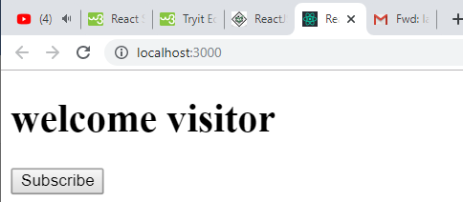

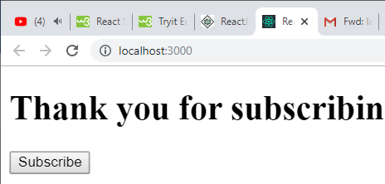

Code:

Index.js

import React,{Component} from 'react';

import ReactDOM from 'react-dom';

class Counter extends Component {

constructor(props){

super(props)

this.state={ count:0 } }

Increment(){

let co=this.state.count+1

this.setState({count:co});

}

render(){

return (

<div>

<h1>counter - {this.state.count}</h1>

<button onClick={()=>this.Increment()}>Increment</button>

</div> );

}

}

ReactDOM.render(<Counter />, document.getElementById('root'));

Index.html

<!DOCTYPE html>

<html lang="en">

<head>

<meta charset="utf-8" />

<meta name="viewport"

content="width=device-width, initial-scale=1" />

<title>React App</title>

</head>

<body>

<div id="root"></div>

</body>

</html>

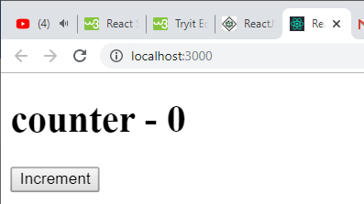

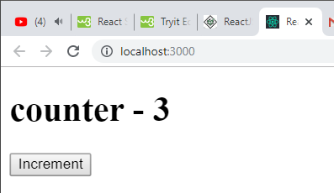

1. Create a timer application which asks the user for minutes. The user then click Start button and starts the timer count down. Preview @ <https://7zyz2y4p5j.csb.app/>

Code:

import React,{Component} from 'react';

import ReactDOM from 'react-dom';

class Counter extends Component {

constructor(props){

super(props)

this.state={

count:'00',

seconds:'00'

}

this.changeHandler = this.changeHandler.bind(this);

this.timerFunc = this.timerFunc.bind(this);

this.timing= this.timing.bind(this);

}

timing(){

if(this.state.seconds==0){

let min= this.state.count -1;

this.setState({

count: min,

seconds: 59,

});

}

else{

let sec= this.state.seconds -1;

this.setState({

seconds: sec,

});

}

}

timerFunc(event){

setInterval(this.timing, 1000);

}

changeHandler = (event) => {

let val=event.target.value;

this.setState({count: val});

}

render(){

return (

<div>

<h1>Timer- {this.state.count} mins: {this.state.seconds} seconds</h1>

<input type="text" name="usertime" onChange={this.changeHandler}/>

<button onClick={()=>this.timerFunc()}>Start Timer</button>

</div> );

}

}

ReactDOM.render(<Counter />, document.getElementById('root'));

Output:

